Project Title
BookMyShow Website – Defect Reporting
Objective
To identify defects in the BookMyShow website and prepare a professional bug report including severity, priority, screenshots, and reproduction steps.
Website
BookMyShow (https://in.bookmyshow.com)
Bug Report 1
Bug ID: BUG-001
Bug Summary: Search accepts blank spaces and displays suggestions.
Module: Search
Severity: Medium
Priority: High
Environment: Android 11, Chrome Browser
Steps to Reproduce:
- Open BookMyShow.
- Tap Search.
- Enter only blank spaces.
- Tap Search.
Expected Result: Search should display an error or ignore blank input.
Actual Result: Suggestions are displayed.
Status: Open
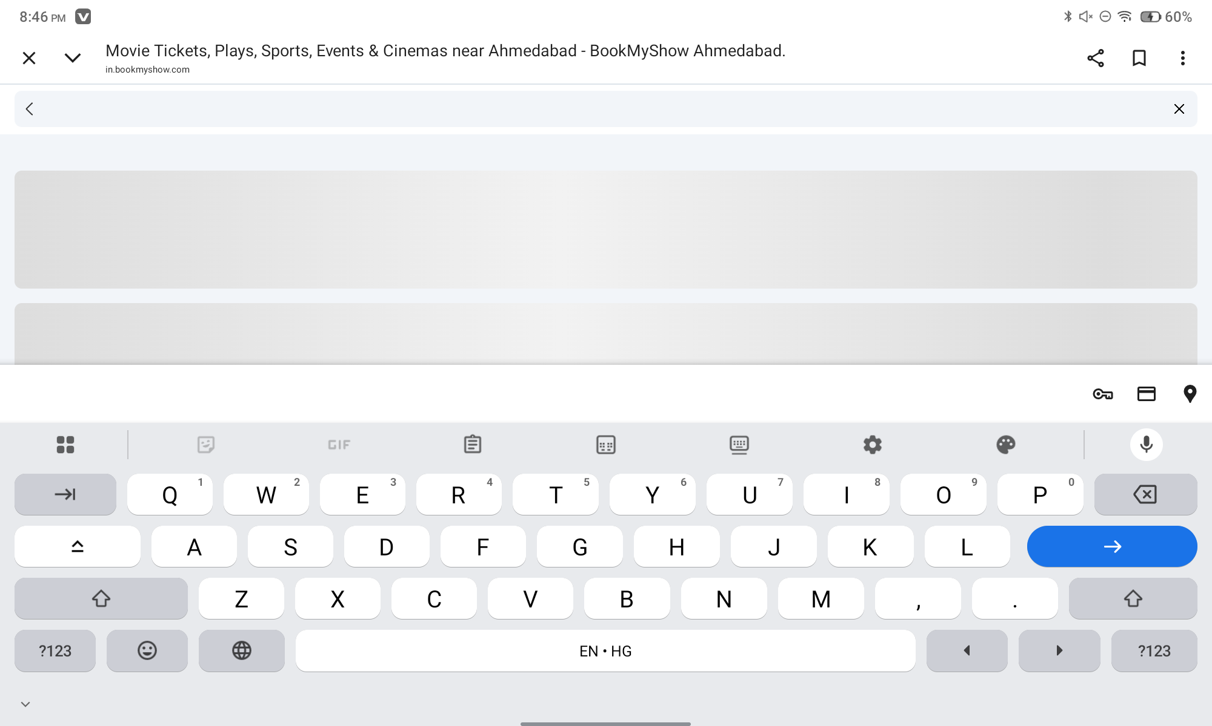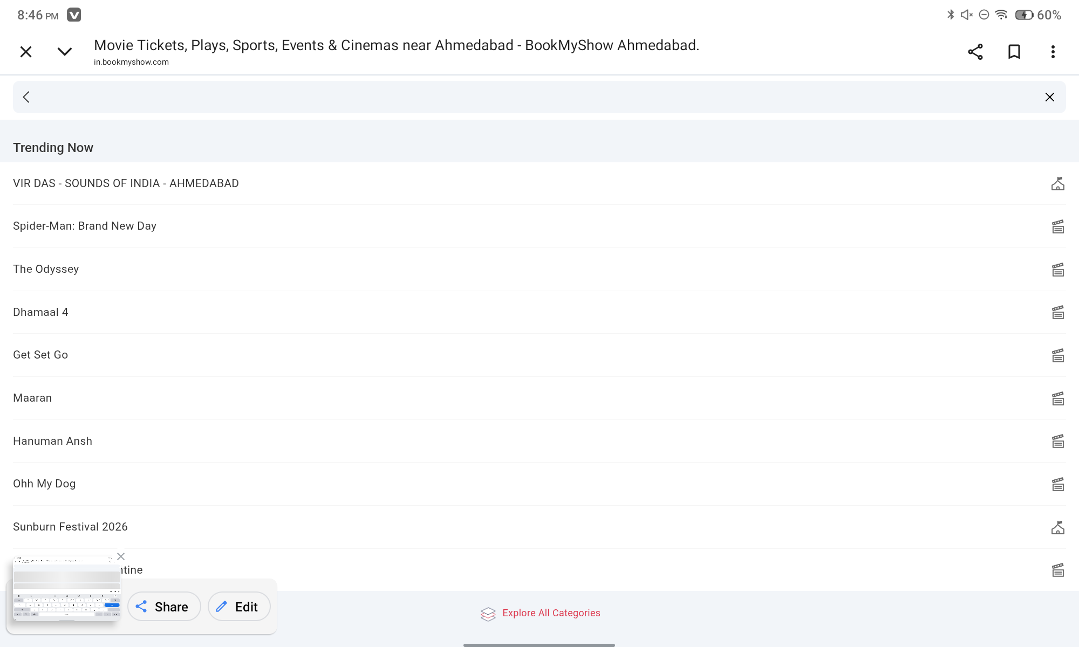
Bug Report 2
Bug ID: BUG-002
Bug Summary: Incorrect password does not indicate remaining login attempts.
Module: Login
Severity: Medium
Priority: Medium
Environment: Android 11, Chrome Browser
Steps to Reproduce:
- Open Login page.
- Enter valid email.
- Enter wrong password repeatedly.
- Click Login.
Expected Result: System should warn about multiple failed attempts.
Actual Result: Only "Incorrect Password" is displayed.
Status: Open
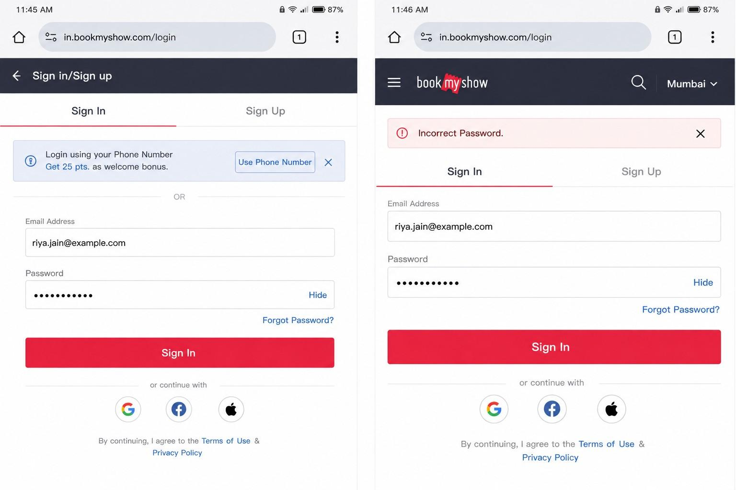
Bug Report 3
Bug ID: BUG-003
Bug Summary: Seat selection page loads slowly during booking.
Module: Seat Booking
Severity: Low
Priority: Medium
Environment: Android 11, Chrome Browser
Steps to Reproduce:
- Select a movie.
- Choose a theatre.
- Open seat selection.
Expected Result: Seat layout should load quickly.
Actual Result: Seat layout takes several seconds to load.
Status: Open
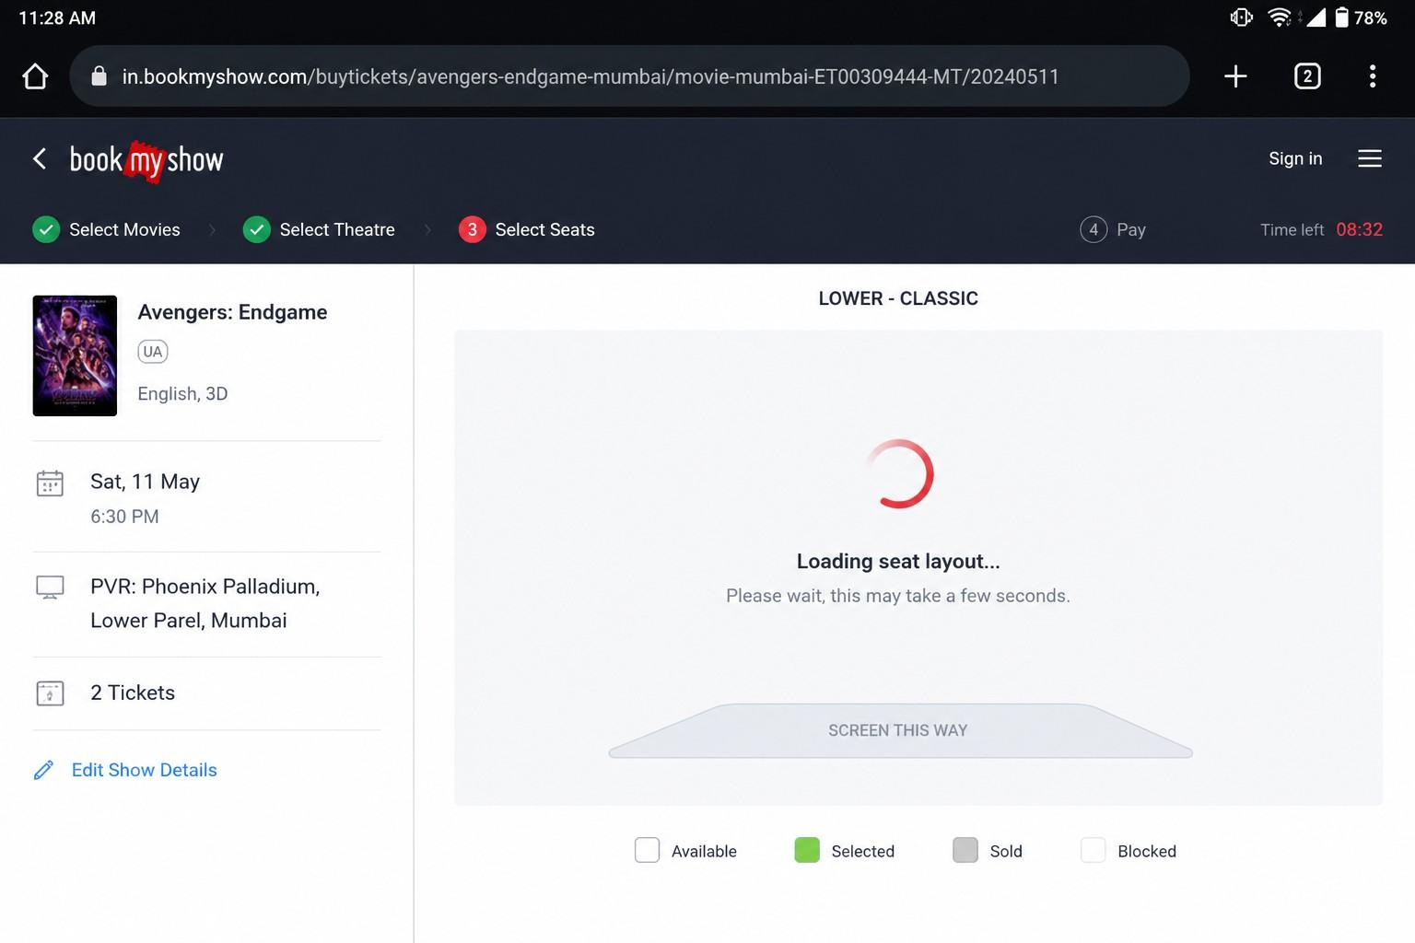
Conclusion
The defects were identified, documented, and prioritized successfully using a standard bug reporting format.

